**Vocabulary**

**Practice exam, 2003, 2008, 2016**

**Bass line:**

* Alberti bass

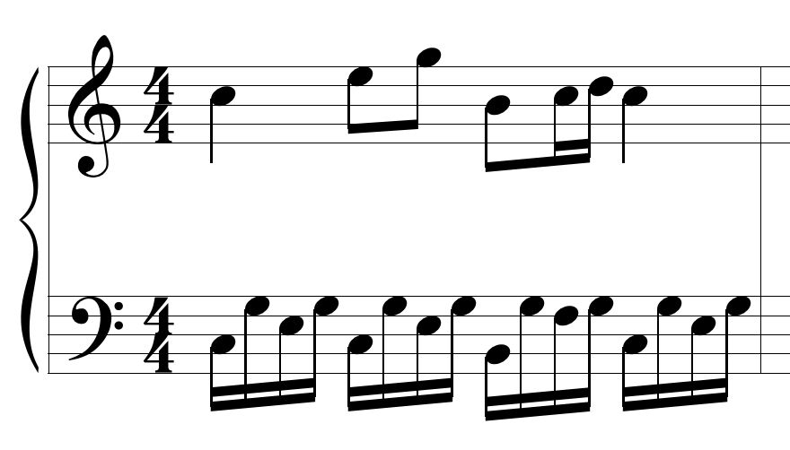

* Ostinato/basso continuo

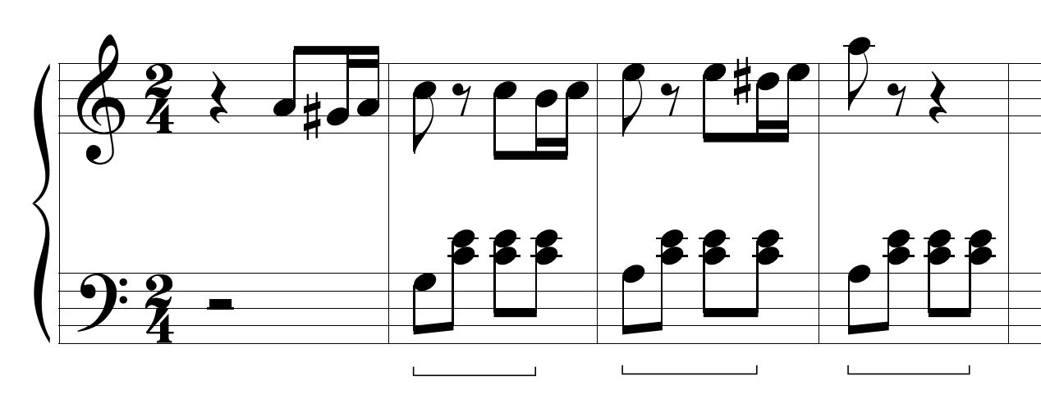

* walking bass
* bass pedal point

**Cadences:**

* PAC
* IAC
* plagal
* half
* deceptive
* phrygian half

**Chords:**

* diminished triad
* minor triad
* major triad
* augmented triad
* dominant 7th
* half-diminished 7th
* fully-diminished 7th
* secondary dominant

**Compositional devices:**

* imitation
* melodic variation

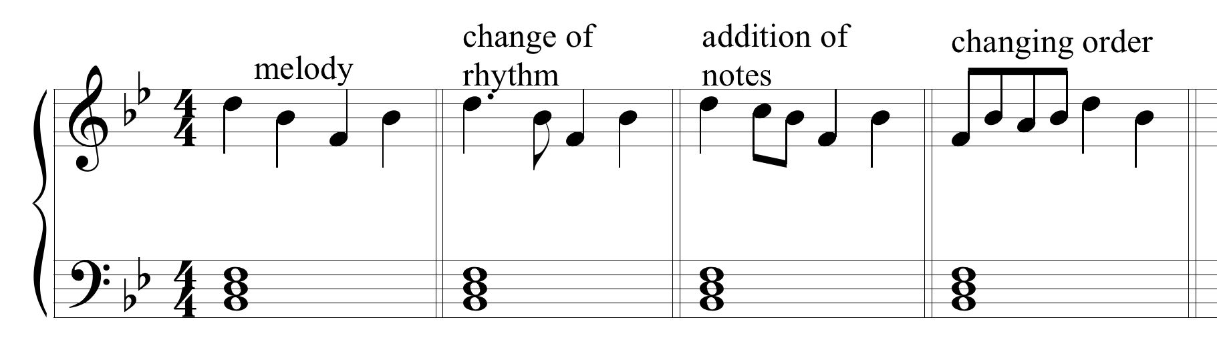

* octave displacement
* deceptive progression
* transposition
* literal repetition
* tessitura
* agogic accent
* voice exchange

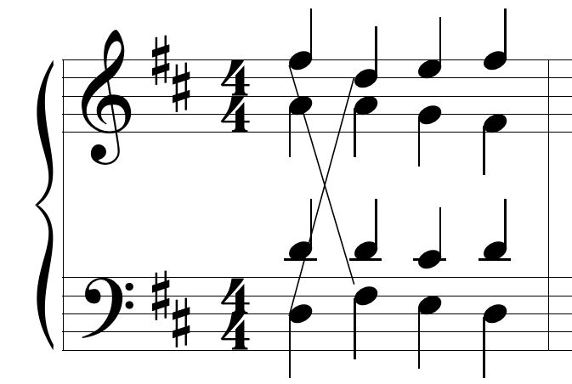

* melodic inversion
* countermelody
* terrace dynamics

**Form:**

* rounded binary form
* binary
* ternary
* theme and variation

**Melodic organization:**

* parallel period (p. 125)
* contrasting period (p. 126)
* double period (p. 128)
* melodic inversion
* sequence

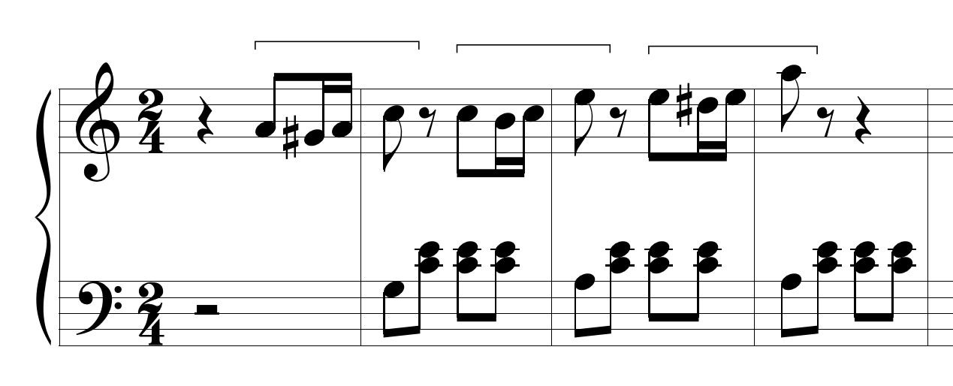

* imitation
* melodic variation
* octave displacement
* sequential repetition
* cadential extension(pg. 127)

**Meter:**

* compound
* simple

**Miscellaneous:**

* Picarcy third
* syllabic
* melismatic
* sforzando

**Motion:**

* parallel
* contrary
* similar
* oblique

**NHT:**

* appoggiatura
* passing tone
* neighboring tone
* anticipation
* escape tone
* neighboring group/changing tones
* suspension
* retardation
* chain of suspensions

**Tempo:**

* adagio
* andantino
* allegro
* andante
* largo
* moderato
* presto
* accelerando
* prestissimo

**Rhythm:**

* anacrusis
* hemiola

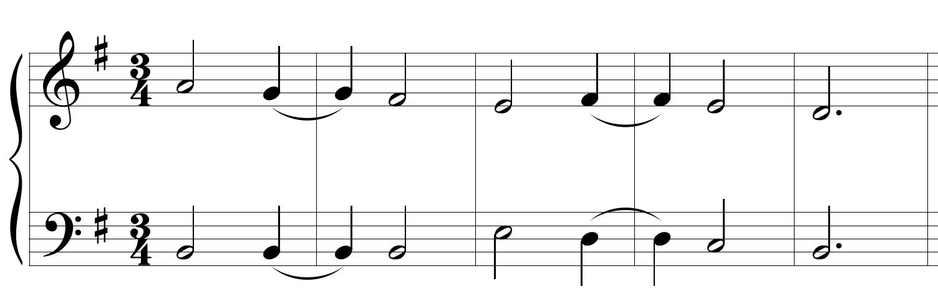

* rhythmic diminution
* cross rhythm
* syncopation
* rhythmic augmentation
* polyrhythm

**Scales:**

* diatonic
* natural minor
* harmonic minor
* melodic minor
* pentatonic
* whole tone
* octatonic
* chromatic
* ionian mode
* dorian
* phrygian
* lydian
* aeolian
* order of modes

**Scale degrees:**

* tonic
* supertonic
* mediant
* subdominant
* dominant
* submediant
* leading tone
* subtonic

**Texture:**

* rhythmic homophony
* homophony/melody with accompaniment
* nonimitative polyphony
* imitative polyphony
* monophony
* heterophony
* chordal homophony

**PW Errors**

* Direct 5ths
* Parallel octaves
* Incorrect spacing
* Doubled leading tone
* Overlapping voices
* Melodic augmented second
* Incorrectly resolved suspension
* Parallel 5ths
* Unresolved chordal 7th
* Unresolved leading tone
* **Know the correct harmonic progression
* **Know the correct use of a 6/4 chord
* Types of 6/4 chords
  + arpeggiated
  + neighboring (pedal)
  + cadential
  + passing